Comment/Sentence Adverbs

🔹 What Are Comment Adverbs (also called Sentence Adverbs)?
# Source: AI Source: Provided by: [Data Path: Persons Table -> ID Column: 1, Name_En Column: Motasem Essam] -> From: [Chatgpt (GPT-4-turbo)] on [7/27/2025]
Comment adverbs (or sentence adverbs) express the speaker’s opinion, attitude, or judgment about the whole sentence, not just the verb.
They are used to comment on the truth, likelihood, or manner of what is being said.

✅ Common Comment/Sentence Adverbs
# Source: AI Source: Provided by: [Data Path: Persons Table -> ID Column: 1, Name_En Column: Motasem Essam] -> From: [Chatgpt (GPT-4-turbo)] on [7/27/2025]
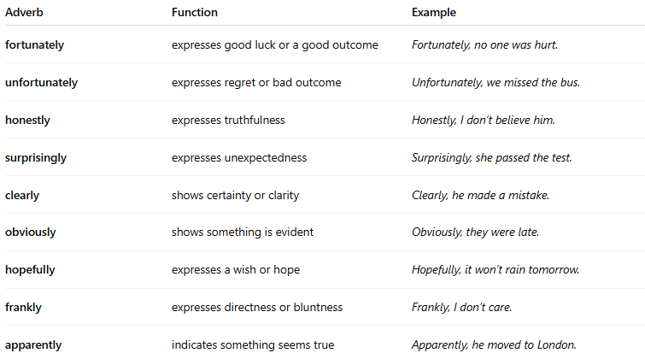
Adverb | Function | Example
fortunately | expresses good luck or a good outcome | Fortunately, no one was hurt.
unfortunately | expresses regret or bad outcome | Unfortunately, we missed the bus.
honestly | expresses truthfulness | Honestly, I don’t believe him.
surprisingly | expresses unexpectedness | Surprisingly, she passed the test.
clearly | shows certainty or clarity | Clearly, he made a mistake.
obviously | shows something is evident | Obviously, they were late.
hopefully | expresses a wish or hope | Hopefully, it won’t rain tomorrow.
frankly | expresses directness or bluntness | Frankly, I don’t care.
apparently | indicates something seems true | Apparently, he moved to London.

🧠 Key Notes
# Source: AI Source: Provided by: [Data Path: Persons Table -> ID Column: 1, Name_En Column: Motasem Essam] -> From: [Chatgpt (GPT-4-turbo)] on [7/27/2025]
- They usually come at the beginning of the sentence, but can also appear in the middle or end:
  - Honestly, I didn’t know.
  - I didn’t, honestly, know.
  - I didn’t know, honestly.
- They apply to the whole idea, not just a single word.

❗ Difference from Other Adverbs
# Source: AI Source: Provided by: [Data Path: Persons Table -> ID Column: 1, Name_En Column: Motasem Essam] -> From: [Chatgpt (GPT-4-turbo)] on [7/27/2025]
- Adverb of manner: modifies how an action is done → He spoke softly.
- Comment adverb: shows the speaker’s attitude → Frankly, he spoke nonsense.

